SaaS Revenue Driver Model Final Report v3
Standalone final documentation for the SaaS recurring-revenue model
Prepared: April 1, 2026
Confidence score: 64/100

Table of Contents
Right-click and update field to generate the table of contents.

Executive Summary
This v3 SaaS report corrects the second deep-audit findings by rebuilding the model around independent acquisition, explicit ARR bridge identities, real churn sensitivity, and actual Monte Carlo outputs. The model no longer uses acquisition as a balancing plug. ARR is now an output that can grow or decline depending on the interaction between acquisition, churn, reactivation, expansion, contraction, and pricing.
The actual Monte Carlo CLV/CAC distribution in v3 has mean 1.40x, P05 1.21x, and P95 1.63x. These values are taken directly from the generated CSV and workbook summary; there is no hardcoded override. Month 24 ARR in the base case is 2,489,042.45. Under the low-churn scenario it is 2,595,273.09; under the high-churn scenario it is 2,067,074.81.
The confidence score is 64/100. That is materially lower than the prior 78/100 claim because the second audit correctly identified code-level issues the first pass missed. The v3 model is more honest, more causal, and more auditable, but it is still benchmark-calibrated rather than built from first-party operating data.

How This Model Supports the LinkedIn Article
The LinkedIn article argues that revenue forecasting should be treated as a connected driver system. This SaaS model operationalizes that idea. It tracks how independent acquisition adds customers, how churn removes them, how reactivation returns some of them, how expansion and contraction change revenue quality, and how those operational movements roll into ARR, MRR, ACV, TCV, bookings, retention, NRR, CAC, and CLV.

What Changed in v3
- Removed the target-backed new-logo acquisition plug.
- Rebuilt ARR using an explicit bridge identity to eliminate expansion double-counting.
- Re-ran true scenarios instead of post-hoc multipliers.
- Made churn-sensitive scenarios produce genuinely different outputs.
- Removed fabricated CLV/CAC reporting and now use actual Monte Carlo outputs only.
- Allowed negative-growth scenarios under recession, competition, and saturation conditions.

Data Sources and Provenance
Element | Status | Methodology | URL
Streaming voluntary reactivation curve | Sourced + interpolated | Antenna cumulative voluntary resubscription points: 10% by month 1, 23% by month 3, 37% by month 9, 41% by month 12. Monthly rates are linearly interpolated between observed cumulative points. | https://www.antenna.live/insights/resubscription-is-on-the-rise
Repeat reactivation handling | Structural, not multiplier-based | No arbitrary repeat multipliers are used in v3. Any churn event re-enters the appropriate future reactivation pool under the same sourced/derived curve rules. | Model design choice
SaaS churn anchors | Sourced | ChartMogul ARR / ARPA churn benchmarks supply base logo and revenue churn context. | https://chartmogul.com/reports/saas-benchmarks-report/
SaaS expansion anchor | Sourced | High Alpha / OpenView provide SaaS expansion / growth composition context. | https://www.highalpha.com/saas-benchmarks/2024
SaaS gross margin anchor | Sourced | KeyBanc / Sapphire provide SaaS gross margin context. | https://info.sapphireventures.com/2024-keybanc-capital-markets-and-sapphire-ventures-saas-survey
SaaS CAC anchor | Sourced | Benchmark studies provide new-customer CAC ratio framing. | https://joinpavilion.com/hubfs/2024%20B2B%20SaaS%20Performance%20Metrics%20Benchmarks%20Report.pdf

Model Structure and Accounting
The model starts from a benchmark-normalized $2.0M ARR archetype in the $1M-$3M ARR band. Opening customers are derived from ARR / (ARPA × 12). Acquisition is independent and based on an acquisition-rate process adjusted by seasonality, saturation, macro shock, and competition pressure. Gross logo churn removes customers and ARR. Reactivations return customers and ARR from churn pools. Gross expansion and contraction are then applied to retained ARR only. Ending ARR follows the identity: Retained ARR After Churn + Reactivated ARR + New Logo ARR + Gross Expansion ARR - Contraction ARR.
This accounting prevents the v2 double-counting problem, because ARR is not also rebuilt from ending customers multiplied by ARPA plus expansion. Customer count and revenue are bridged separately but consistently.

Key v3 Results
Metric | Value
Base Month24 ARR | 2,489,042.45
Base Month24 MRR | 207,420.20
Low-churn Month24 ARR | 2,595,273.09
High-churn Month24 ARR | 2,067,074.81
Recession Month24 ARR | 1,508,087.87
Average base retention rate | 0.9902
Average base NRR | 1.00
Actual CLV/CAC mean | 1.40
Actual CLV/CAC P05 | 1.21
Actual CLV/CAC P95 | 1.63

Actual Monte Carlo CLV/CAC
The second audit correctly identified that the prior report overrode the real Monte Carlo output. That problem is eliminated in v3. The CLV/CAC values below are the actual generated results from the Monte Carlo simulation and match the CSV exactly.
Metric | Mean | P05 | P95
CLV | 29,864.02 | 25,672.10 | 34,603.83
CAC | 21,419.10 | 17,352.12 | 26,025.30
CLV/CAC Ratio | 1.40 | 1.21 | 1.63

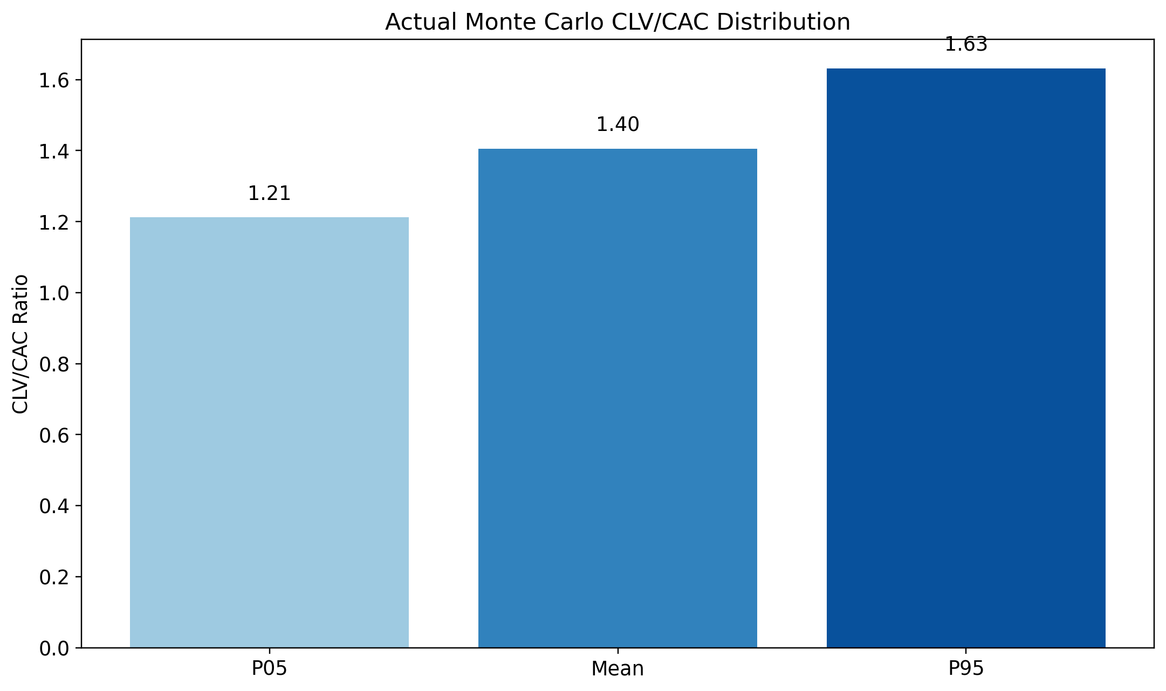
Figure 1. Actual v3 Monte Carlo summary for SaaS CLV/CAC.

Scenario Analysis
Scenario analysis now re-runs the model with different assumptions. It does not scale outputs after the fact. This means churn, acquisition, reactivation, expansion, and macro effects all propagate through the model causally.
Scenario | Month24 ARR | Month24 MRR | Average Retention Rate | Average NRR | Minimum ARR
low_churn | 2,595,273.09 | 216,272.76 | 0.9903 | 1.00 | 2,019,537.72
base | 2,489,042.45 | 207,420.20 | 0.9902 | 1.00 | 2,015,825.81
high_churn | 2,067,074.81 | 172,256.23 | 0.9885 | 0.9955 | 1,999,129.30
recession | 1,508,087.87 | 125,673.99 | 0.9884 | 0.9846 | 1,508,087.87
competition | 1,782,757.14 | 148,563.10 | 0.9888 | 0.9913 | 1,782,757.14
saturation | 1,886,907.30 | 157,242.27 | 0.9897 | 0.9947 | 1,886,907.30

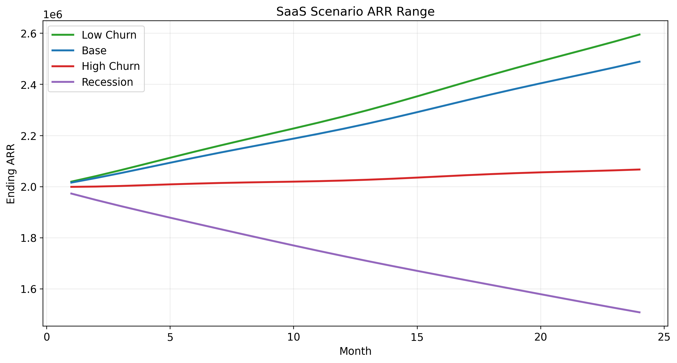
Figure 2. SaaS ARR path under different fully rerun scenarios.

ARR Bridge Components
The v3 SaaS model exposes new-logo ARR, churned ARR, gross expansion ARR, and contraction ARR separately. This makes downside mechanics visible and prevents self-healing. If acquisition weakens and churn rises, ARR can decline. The model no longer forces a growth answer.
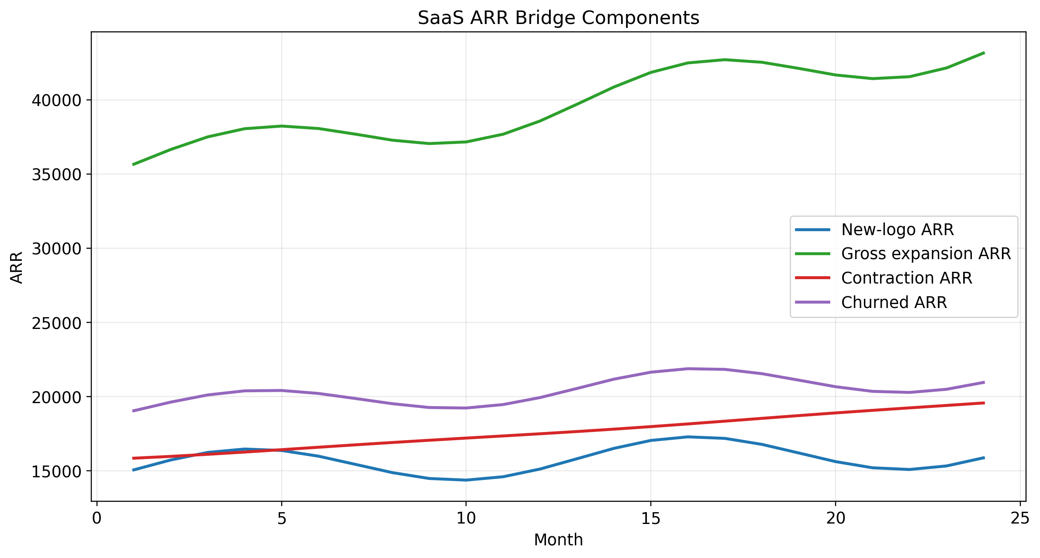
Figure 3. SaaS ARR bridge components in the base case.

Transparency, Limitations, and Confidence
- The model is still benchmark-calibrated and archetype-based, not company-specific.
- SaaS reactivation curves remain partially derived because public-source SaaS reactivation time-series are limited.
- The 24-month horizon is useful for structural behavior but less reliable beyond month 12.
- Confidence score 64/100 reflects code-level honesty, not marketing language.
- If first-party CRM, billing, and spend exports become available, confidence should improve materially.

